

TNE20003 – Internet and Cybersecurity for Engineering Applications

Portfolio Task – Project

Leo Holden
Submission date: 25/10/2024

Contents
Introduction 3
MQTT 3
Cybersecurity Issues 3
i – Social Engineering & Phishing 3
ii – Peeking and Passwords 4
iii – Denial of Service 4
iv - Encryption and TLS/SSL 4
v – Conclusion 4
Code 5
References 7

Introduction
This project encompasses the unit of study topics through out semester to consolidate and showcase individual learning obtained. The base requirement is to develop a prototype application in python utilising already existing Internet of Things (IoT) infrastructure – MQTT system. Fake data needs to be formed to test the applications. Furthermore, this report concerned with the cybersecurity issues apparent in the solution. Additionally, information about the source code. My solution involves communication of vault keypad lock and control computer through MQTT and detecting brute force attempts.

MQTT
An overview of MQTT (Message Queuing Telemetry Transport), it is – lightweight and efficient, bi-directional communication, scalable, reliable message delivery, support for unreliable networks and security enabled [1]. MQTT functions by having a broker that handles routing messages from source to destination. Clients subscribe – receive or publish – send, data to specified topics. Broker can be thought of a postage service, mail from origin is sent to post office (broker) then the post office delivers to destination. Topics are hierarchical and are like listening channels. E.g. vault/DepositBox254/sensor, clients subscribe to this topic results in receiving messages published to it.

Cybersecurity Issues

i – Social Engineering & Phishing
Physical security is placed above everything, all technical security implementations is forfeited if physical security is not ensured with absolute certainty. This means restricting access certain areas and such as a servers or internal systems, an employee's desktop and laptop or their ID card.
Social engineering is the action of gaining information from someone that should not told, in a seemingly non-malicious but deceptive way. Threat actors may achieve this online, phone calls or in-person. They may ask questions which its answers without notice seem like nothing but reveal valuable information. E.g. threat actor asks about food places around the area, revealing potential places employees may regular. From here technical or further social engineering techniques could be used.
Although social engineering can be used to directly reveal sensitive information. Phishing is an online method of carefully constructed messages or emails that con someone into revealing information. Phishing could be replicating legitimate emails even from the company they work for and may also contain malware links or downloads.
Counteracting social engineering and phishing attacks comes down to training staff and employees about these sorts of acts. That they should not be answering certain types of questions, that if emails or messages asking for revealing details, even if appearing legitimate should not be answered too.

ii – Peeking and Passwords
The GUI of MQTT is made to be usable, not secure. Peering over someone’s shoulder whilst they are using the application can reveal some sensitive fields including username, name, topics, ports, hostname, and receiving and sending messages.
To prevent occurrences of peeking, employees so ensure that they lock their device when unattended. And being aware of suspicious behaviour of others in proximity. Require password login, using password hashing to store the passwords. Password policies - passwords must meet a threshold of complexity level and must be changed an arbitrary amount of elapsed timed e.g. 3 months. Passwords history should be considered and dealt with ensuring that users are not having the technically different but similar password with incremental value appended e.g. Pa55w.rd1, Pa55w.rd2, Pa55w.rd3 etc.

iii – Denial of Service
MQTT protocol being lightweight does not offer action control. Denial of service (DOS) is the action of overwhelming the systems processing ability resulting slow or complete service denial through networking actions like requests or posts. In the case of MQTT, if a topic and hostname has been discovered or access to the system is gained – attackers can overflow the broker or client by publishing large amounts of messages. Disruptions can affect entire network. Implement packet size maximums, rate limiting and connection throttling.

iv - Encryption and TLS/SSL
As stated, MQTT is a lightweight protocol meaning it will not deal with the security of messages. This comes off as a trade-off for better performance with network instability and low power mode devices by which it was designed for. Currently the implementation of the MQTT broker is using port 1883 which is not secure and will transmit messages in plain text. Applying this deployment of the model is highly unsecure. The system would be at threat of not only the exposing message contents but damages to the internal site systems.
Interception of packets can result in threat actors tampering with them and altering or inserting payloads. Transmission in plaintext means confidential information like credentials are exposed to attackers.
MQTT can however be configured to transmit over port 8883 which is the secure alternate running TLS/SSL, encrypting data over transmission. This would require alterations in source code for applications connected to the broker and broker reconfigurations. The company would have to obtain private and public keys for the broker and clients and certificates. Keys and certificates are to be used for authentication for both clients and broker - Access Control. Therefore, secure connections can be made to off site, additional security like a VPN can work in conjunction with TLS/SSL too.

v – Conclusion
When considering security implementations, the application and its intended purposes must be relevant when deciding upon them. There are finite computing resources and there are financial costs involved. Trade-offs must be made to fit what is necessary. CIA (Confidentiality Integrity Availability) is a security principle that can provide information about making trade-offs.

Code
The base idea of vault keypad lock and control computer is that because it connects to the internal network and if moving the deployment offsite, anything connected to the internet is at risk. Potential attack could come through is a brute force password attack. Limiting the amount of password attempts and if exceed deny any more attempts. The vault keypad will contact the control computer, to which issues an override command to the keypad.
zVaultlockpad.py, zControlComputer.py don’t offer any control over what topic is subscribed to other than what is predefined. Publishing is the same – predefined topic, the messages are generated in both programs making arbitrary data to send for demonstration purposes. zControlComputer.py has the code to which responds to a trigger event (when login attempts > 5). zMonitorApp.py is the monitoring application which allows for more control over what the application is doing. And has nicely formatted headers printed screen for both sending and receiving displaying which topic.

ZMonitorApp.py
Recv
Figure 1
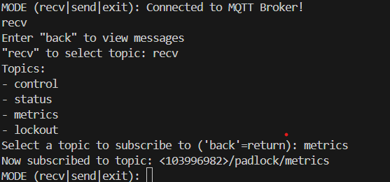
- Selecting recv: will put you take you to selecting a topic to listen to, setting current_mode to ‘receive_menu’. This is preventing receiving messages from printing to the screen potentially disrupting the screen if already subscribed to a topic.

- ‘back’ will return to main prompt and current_mode is set to ‘receive’ and will begin printing messages again.
- ‘recv’ will advance to topic selection.

- Selected topic will be printed to the screen and return to main prompt – also setting current_mode to ‘receive’.

Send
Figure 2
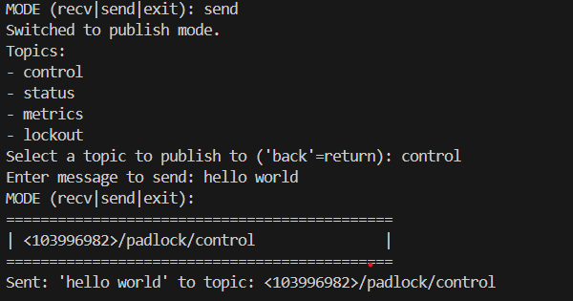
- Similar to recv in output, prompts for topic choice and message input, then prints message, and header with chosen topic. (Hitting ‘enter’ will bring up main prompt if nothing is shown after entering message)
- Current_mode however is set to ‘publish’ stopping receiving messages from being printed and remains after sending message. To see printing messages, you should enter ‘recv’ mode again then enter ‘back’.
Receiving message and displaying
Figure 3
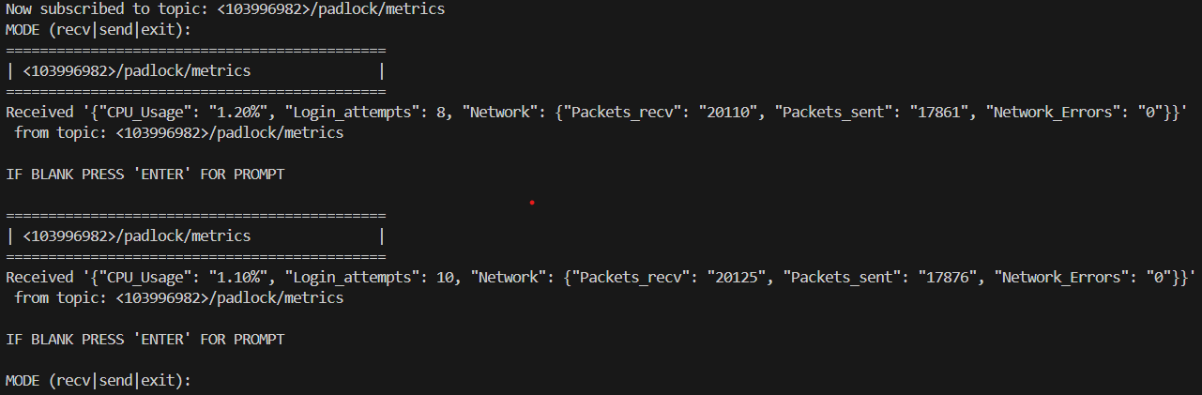
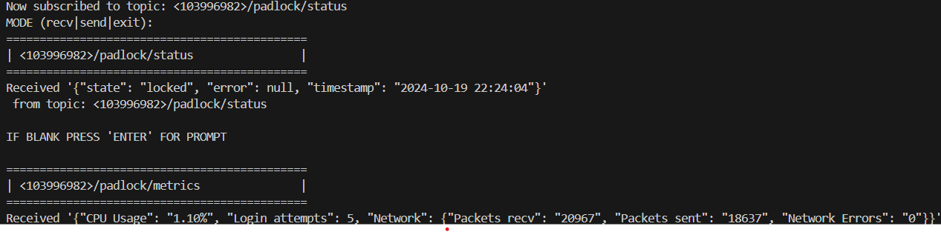
Figure 4

- Subscribing to metrics and receiving messages from zVaultPadlock.py. (top)
- Note: you can subscribe to multiple topics and receive messages from all. (bottom)

Event trigger response
Figure 5
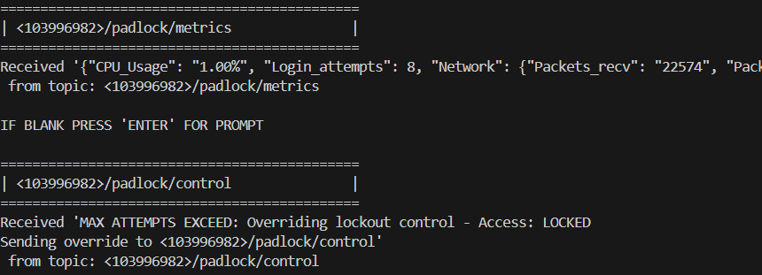
Figure 6
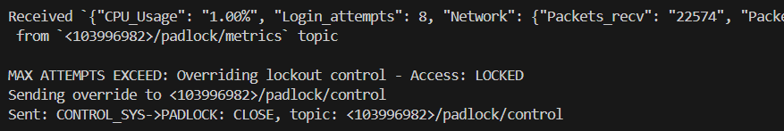
- Figure 5 shows zMonitorApp.py subscribed to metrics and control, figure 6 is zControlComptuer.py receiving data from zVaultPadlock.py and generating the response data and sending it to control.

References

[1] | MQTT.org, “MQTT: The standard for IoT messaging,” n.d.. [Online]. Available: https://mqtt.org/. [Accessed 19 October 2024].
[2] | D. Tao, “MQTT in Python with Paho Client: Beginner's Guide 2024,” EMQX, 2 August 2024. [Online]. Available: https://www.emqx.com/en/blog/how-to-use-mqtt-in-python. [Accessed 19 October 2024].

